Juan Villegas HW 04
Stage 1 – Problem Understanding
Because I am in the market for a used car -At the worst time imaginable- I will use data science to get insights on the used cars market. I am using the Used Cars Dataset from Kaggle. I hope that by using data science, I will get a better understanding of what variables affect the probability of a variable being in my budget of 15k. Ultimately, I want to create a CART model to show me what the most efficient way to look for a used car in my budget is.
Stage 2 – Data Pre-Processing
My first step was to acquire the data and clean it up a little bit on excel. I removed the Audi make because using R, I found that the Audi data frame had a lot of data entry errors. (There was different data sets for different makes of cars. I made a master excel .csv file for all the makes.) I also created a ‘makes’ variable, and a ‘USDPrice’ variable. Lastly, I removed the cars that had errors in their values like: a 2060 Ford and vehicles that had ‘0’ for their engine value (They could’ve been EV’s because EV’s have batteries but, after looking the vehicles up, they had engines).
I continued Data Pre-Processing on R by creating a target variable “Under 15k” and Identifying outliers using univariate graphs on numeric variable. I then transformed the numeric variables into factors (categorical variables) by binning values.
Stage 3 – Exploratory Data Analysis
During my EDA stage, I created univariate graphs for my target and predictor variables:
First I created Histograms & boxplots for my numeric variables and then I turned them into categorical variables and created bar plots for them:
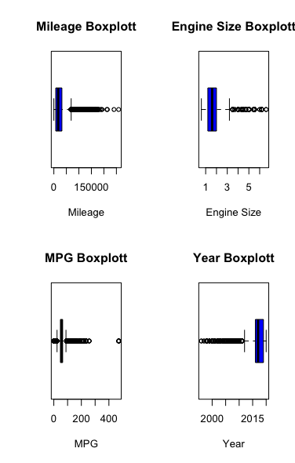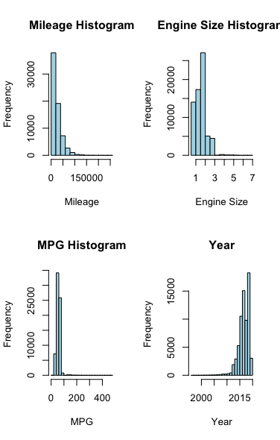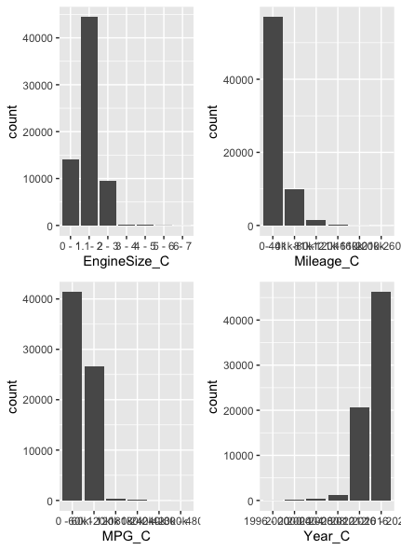

Then I created Barplots for my categorical variables:
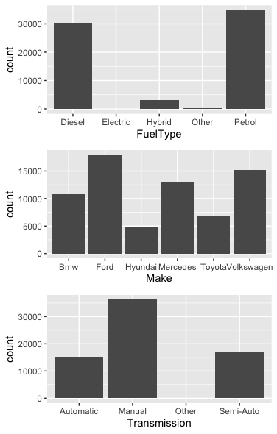
Αφτερ τηατ, Ι μοϖεδ οντο μψ βιϖαριατε γραπησ. Ι πλοττεδ τηε χατεγοριχαλ ϖαριαβλεσ ωιτη μψ ταργετ ϖαριαβλε (βυδγετ) ασ τηε οϖερλαψ. Ι πυτ τηε οϖερλαψ ιν 3 διφφερεντ ποσιτιονσ ον τηε γραπησ:
Dodge:
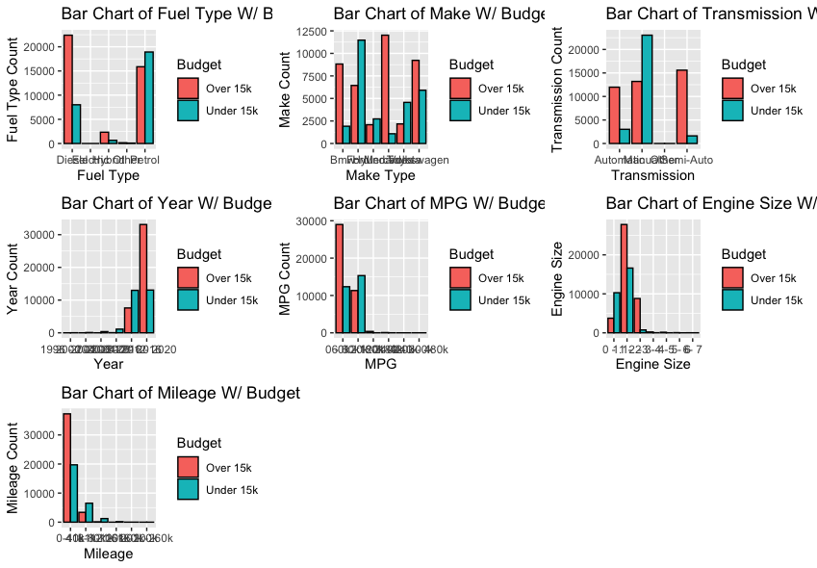

Stacked:
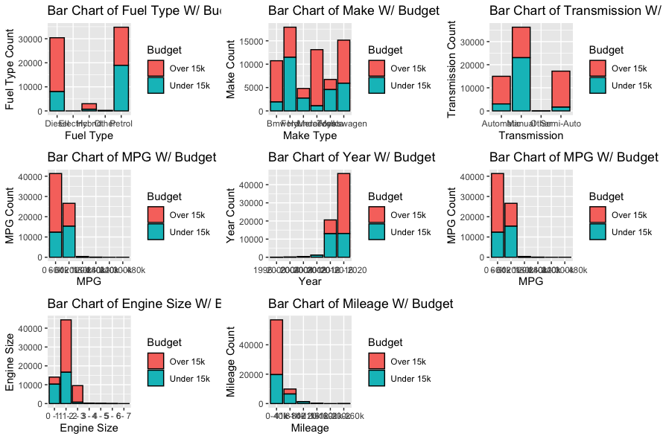
Filled:
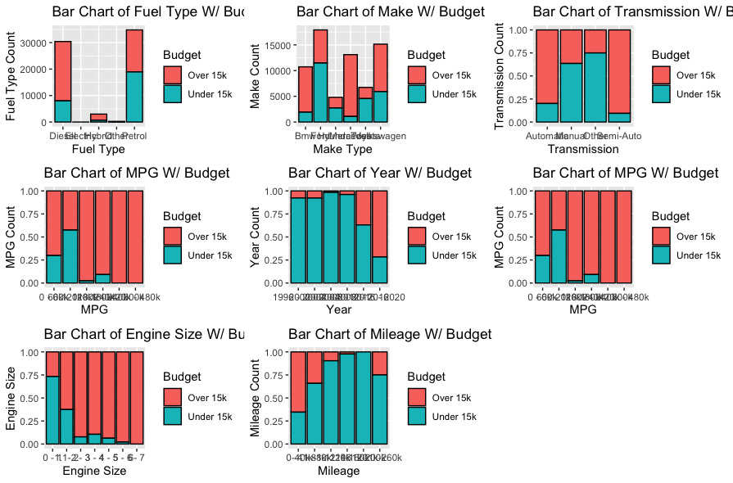
Τηεν, Ι χρεατεδ τριϖαριατε δισπλαψσ φορ μψ νυμεριχ ϖαριαβλεσ ωιτη αν οϖερλαψ οφ μψ βυδγετ:
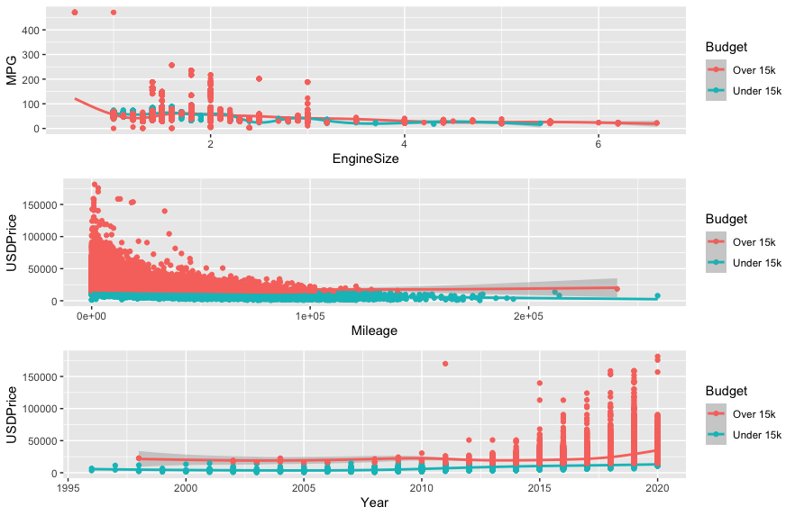

I continued by binning a few variables based on predictive values and making continency tables: 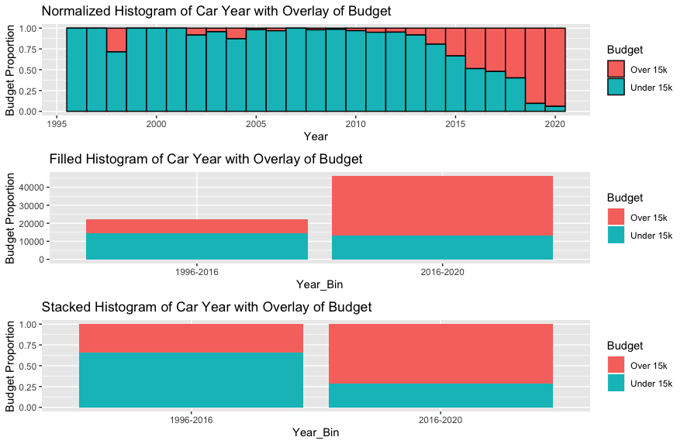
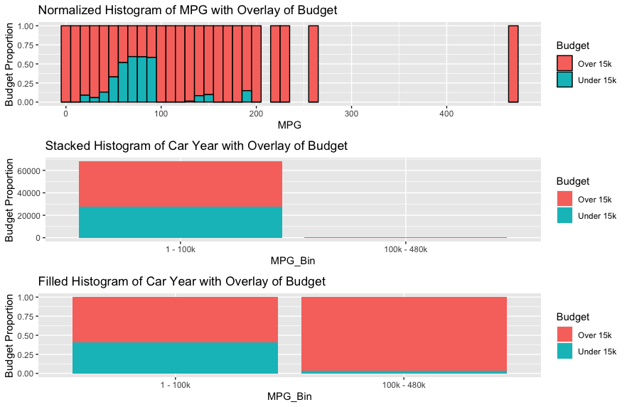
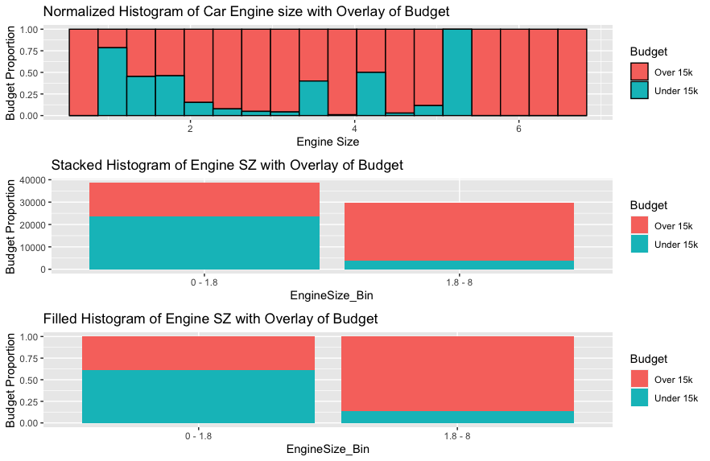
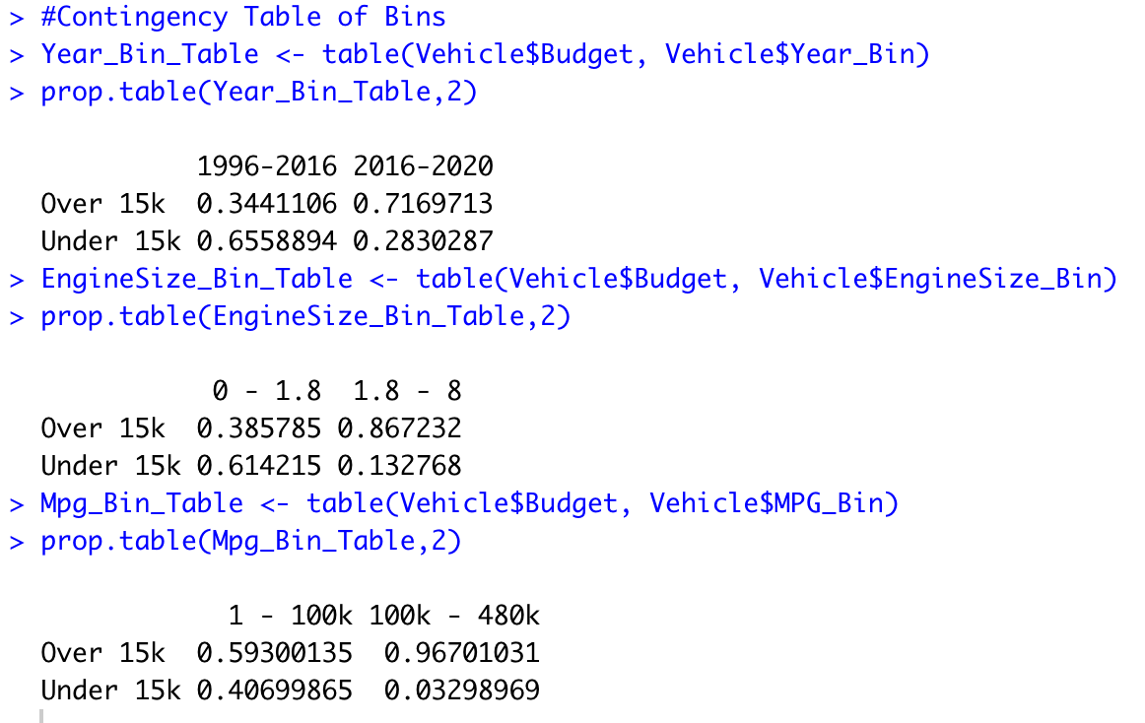
And finding the correlations between continuous variables.
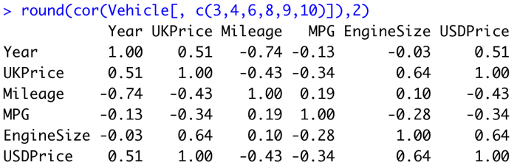
HW 04 Check List

Stage 1 – Problem Understanding
Clearly enunciate the project objectives
Translate the objectives into the formulation of a problem that can be solved using data science
Stage 2 – Data Pre-Processing
Identify redundant variables, data entry errors, and other candidates for removal
Identify and handle missing data
Identify any outliers
Transform and standardize the data
Reclassify categorical variables
Bin numerical variables
Stage 3 – Exploratory Data Analysis
Univariate graphs and tables for predictors and target variable
Bivariate graphs and tables for predictors’ relationship with target variable
Trivariate graphics, such as scatterplots with an overlay of the target variable
Binning based on predictive value
Derive new variables

